**SE305 Project Phase 2 Evaluation**

|  |  |  |  |
| --- | --- | --- | --- |
| **Project** **Title**: Razzaz Tours | | | **Team Number** : 01 |
| **Items** | **Weight** | **Grade** | **Notes** |
| Design viewpoints | 10 |  |  |
| Data Design | 5 |  |
| User Interface Design | 1 |  |
| Requirements Matrix | 1 |  |
| Correct Citation (minimum 4 references) | 1 |  |
| Project Plan and task distribution | 1 |  |
| Document is clear, complete, and consistent | 1 |  |
| **SDD Document Grade** | **20** |  |
| Achievement of project scope | 5 |  |
| Data validation (Front end + Back end) | 5 |  |
| Code is correct, clear, integrated and consistent. Implementation conforms with the design. | 10 |  |
| CRUD operations (As per the functional requirments) | 10 |  |
| Using OOP, EAV, and Design Patterns | 10 |  |
| Using MVC | 20 |  |
| **Project Implementation Grade** | **60** |  |
| **Bonus** | | |
| Hosting the application | 5 |  |
| Product Owner Feedback | 5 |  |
| System Testing | 5 |  |
| **Project Total Grade** | **80** |  |

# **Team Individual Evaluation and Final Grade**

|  |  |  |  |  |  |
| --- | --- | --- | --- | --- | --- |
|  | **ID**  [Ordered] | **Full Name** | **Discussion (10)** | **GitHub**  **(10)** | **Total (100)** |
| **1** | 2018/16726 | Ammar Ahmed Mohamed |  |  |  |
| **2** | 2018/05110 | Karim Yasser Samir |  |  |  |
| **3** | 2018/04369 | Mohammed Tarek Mohammed |  |  |  |
| **4** | 2018/10751 | Mostafa Khaled Abo Elenain |  |  |  |

Assessor Name : Assessor Signature :

# **Project Information**

**Live Application URL:**

# Abstract

Razzaz Tours is a company that helps people book services, promotes domestic tourism in Egypt, and provides recommendations for the best places to visit during their holidays, such as Sharm El-Sheik and Gouna. Alongside, assist visitors in determining their programs by looking at the previous experiences of other viewers during their quest for a program. Razzaz Tours collected all of the reservations such as reserving trip and museum, or program in only our web application. Besides the custom service that plays an important role in the application. As developers, we intended to apply an incremental development process instead of taking risks and try to achieve free bugs application. The suggested solution is a web application that will assist users in planning a leisure and tourist itinerary. These can help them have a wonderful time in Egypt while still using our web application.

# Application Overview

Include System overview diagram, use case diagram and screen shots of the application main screens.

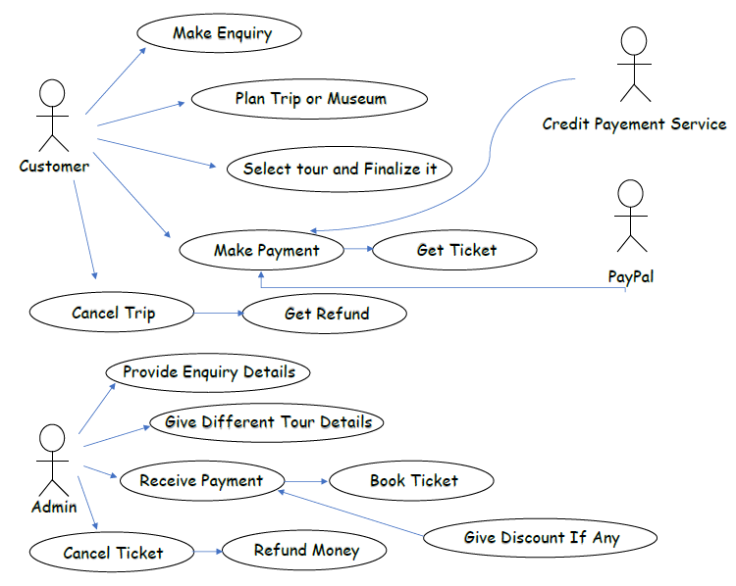

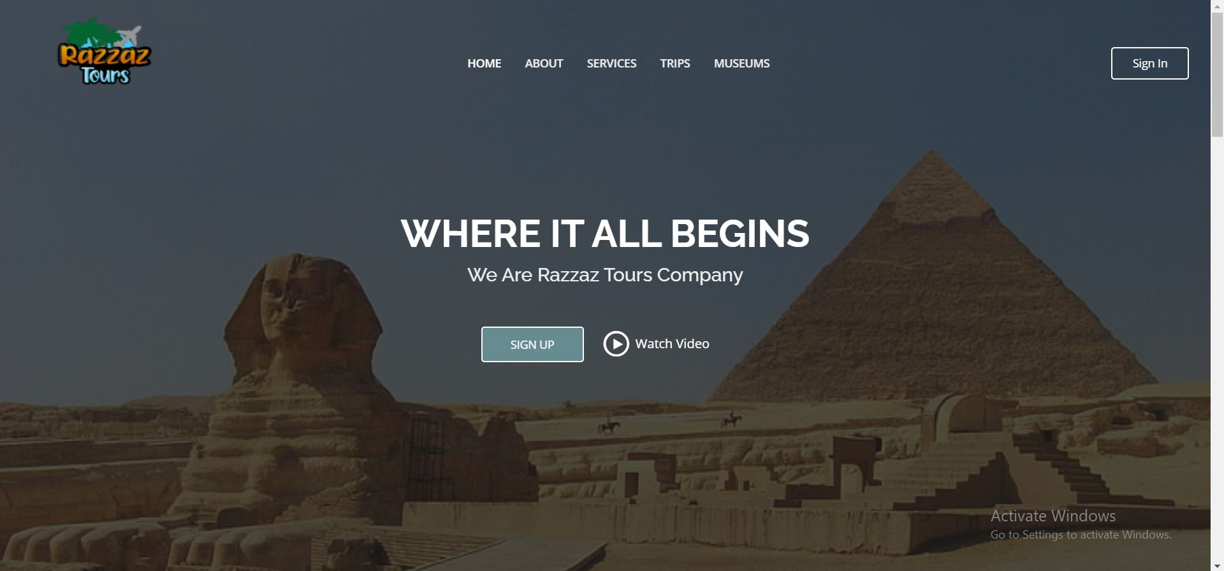

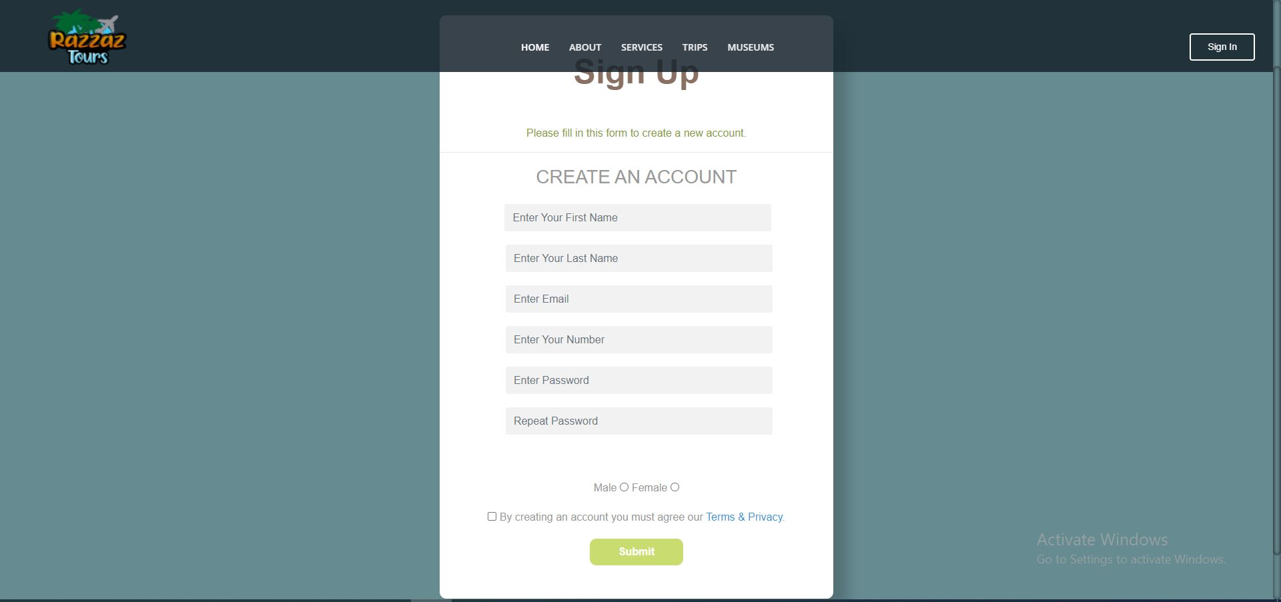

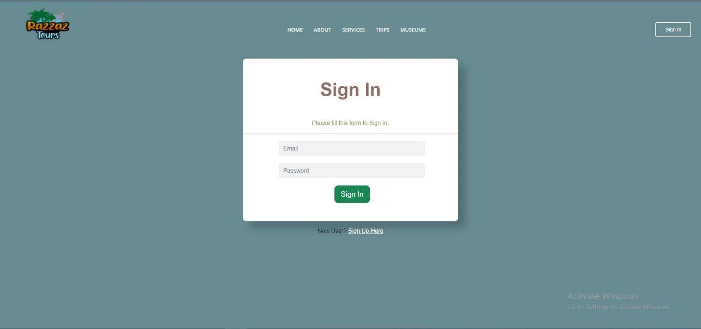

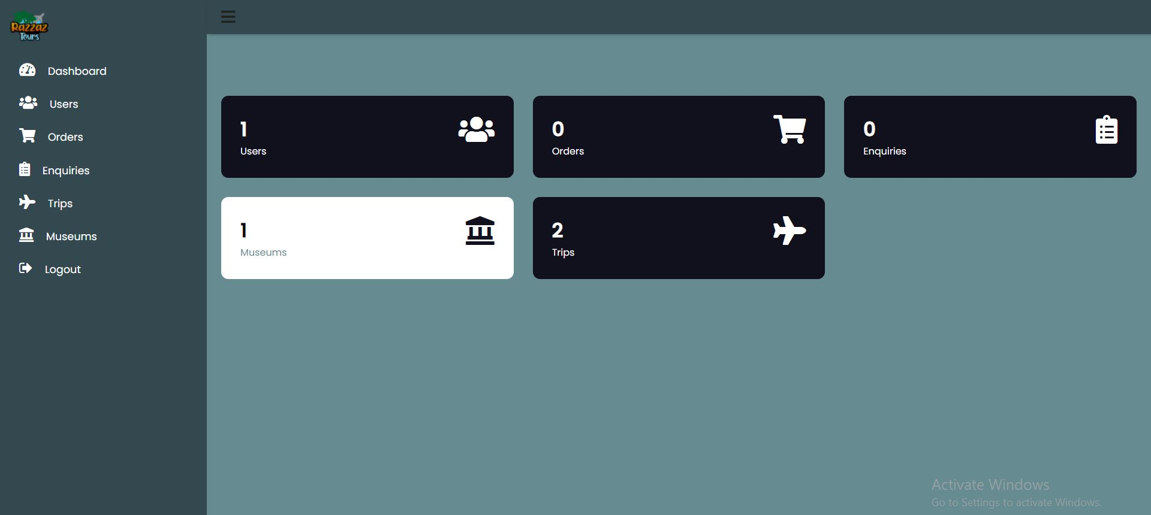

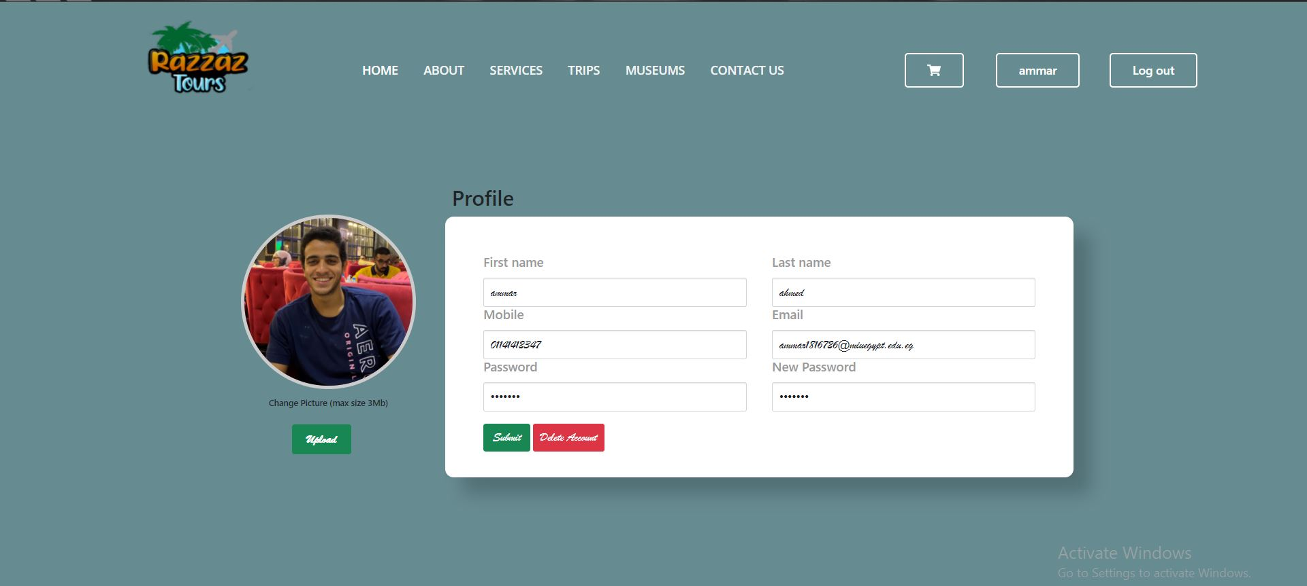

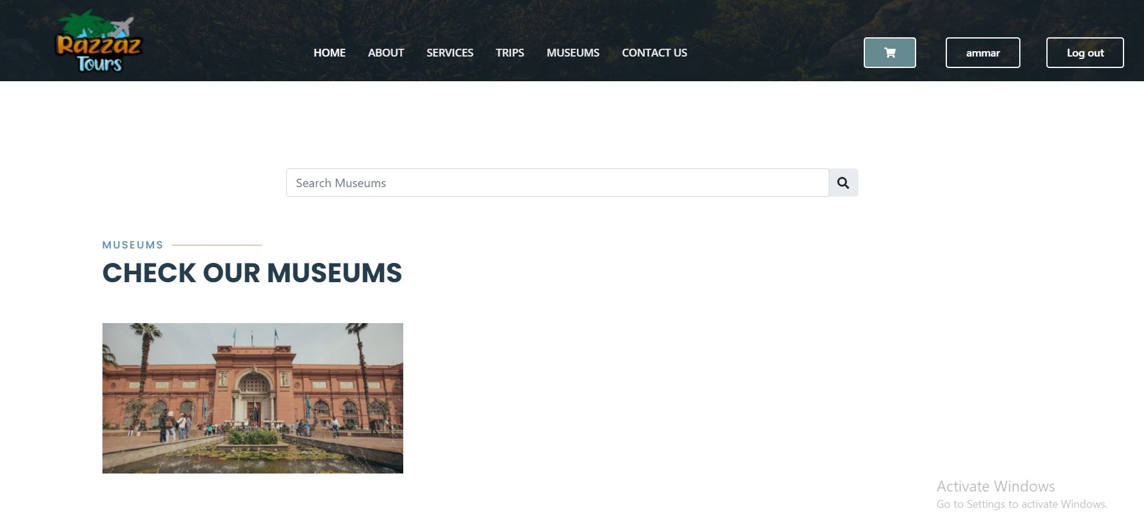

# 

# 

# GitHub repository

**GitHub URL:** <https://github.com/kareem337/razzaz>

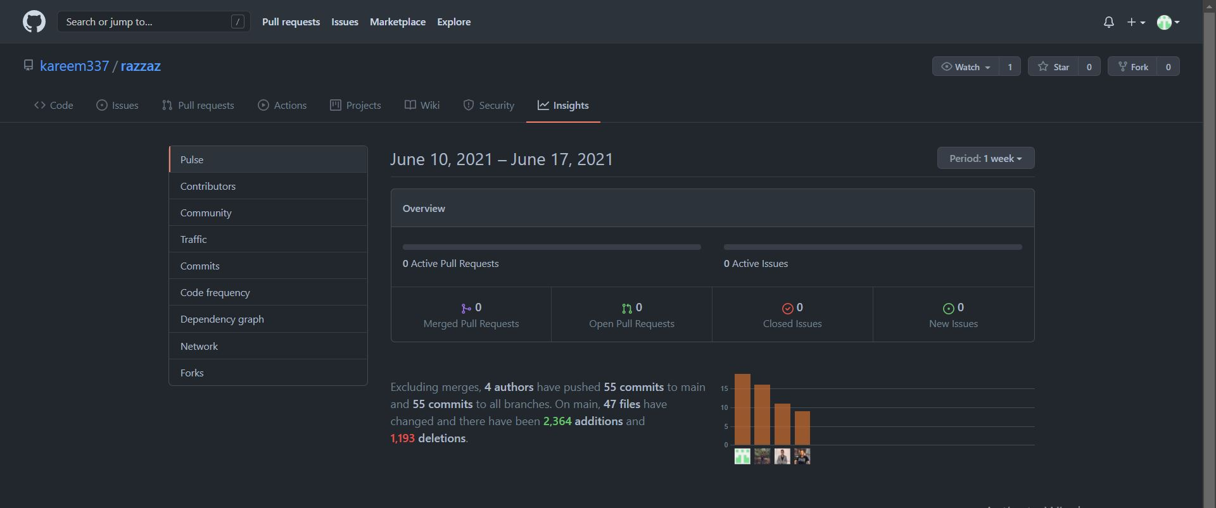

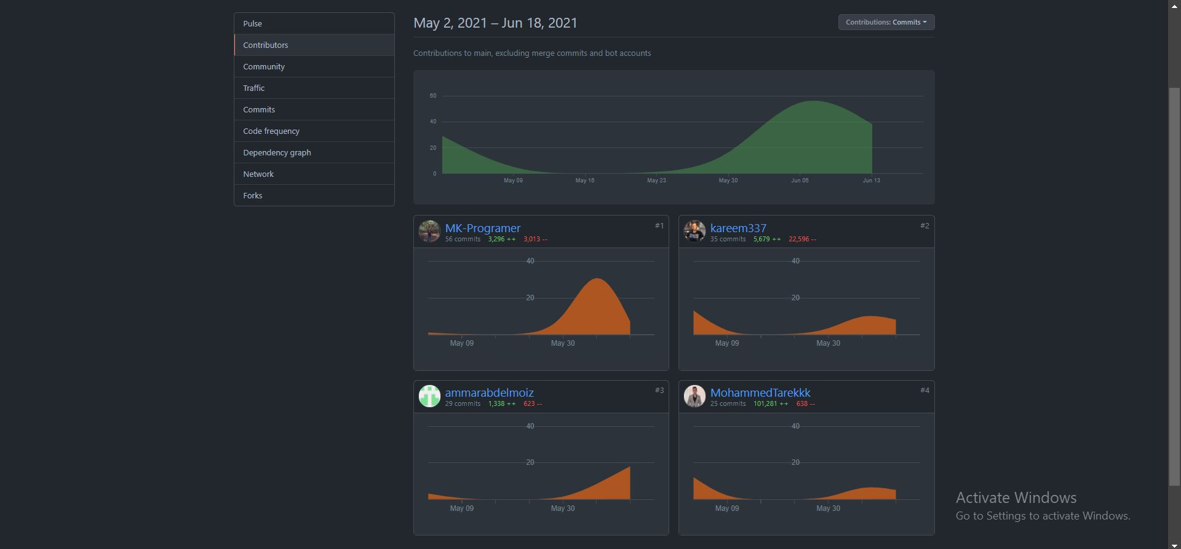

# Tasks distribution:

|  |  |  |  |  |  |
| --- | --- | --- | --- | --- | --- |
| ID | Task name | Description | Start date | Duration | Assigned team member |
| 1 | Home Page | Viewed to the user before and after sign in. | 25/5 | 4 | Kareem Yasser /  Mostafa Khaled |
| 2 | Trip Page | Viewing to the user trips available for reservation. | 28/5 | 4 | Kareem Yasser /  Mostafa Khaled |
| 3 | Booking Page | Viewing to the user the description of each trips such as price, description, rating and comments. | 28/5 | 3 | Mostafa Khaled /  Kareem Yasser / |
| 4 | Cart | Viewing the products that the user will buy. | 1/6 | 2 | Kareem Yasser /  Mostafa Khaled |
| 5 | Edit Profile | Edit the profile of the user or admin. | 1/6 | 3 | Mohamed Tarek /  Ammar Ahmed/  Kareem Yasser/  Mostafa Khaled |
| 6 | Navigation Bar | Controller of the system of user and admin. | 28/4 | 1 | Mohamed Tarek /  Ammar Ahmed/  Kareem Yasser/  Mostafa Khaled |
| 7 | Footer | Extra information about the system. | 10/6 | 2 | Ammar Ahmed |
| 8 | Services | Services that the system will provide. | 28/5 | 2 | Mohamed Tarek /  Ammar Ahmed/  Kareem Yasser/  Mostafa Khaled |
| 9 | Contact us | Contact with the custom service for enquiry. | 10/6 | 3 | Mohamed Tarek /  Ammar Ahmed/  Kareem Yasser/  Mostafa Khaled |
| 10 | Sign in | Sign in. | 1/6 | 2 | Mostafa Khaled / Kareem Yasser/ Mohamed Tarek |
| 11 | Sign up | Sign up. | 1/6 | 2 | Kareem Yasser / Mohamed Tarek/  Mostafa Khaled |
| 12 | Admin | Pages for admin view | 28/5 | 4 | Mohamed Tarek /  Ammar Ahmed |
| 13 | Writing | Text in the system. | 6/5 | 1 | Kareem Yasser |
| 14 | Pictures Chosen | Pictures used in the system. | 6/5 | 1 | Kareem Yasser |
| 15 | Add/Edit Users | Admin can add edit search users. | 28/5 | 3 | Ammar Ahmed /  Mohamed Tarek |
| 16 | Add/Edit Trips | Admin can add edit search trips. | 28/5 | 4 | Ammar Ahmed / Mohamed Tarek |
| 17 | View Orders | Search for an order. | 1/6 | 2 | Ammar Ahmed / Mohamed Tarek |
| 18 | Data Base Design | Designing the database | 25/5 | 4 | Mostafa Khaled /  Kareem Yasser /  Ammar Ahmed/  Mohamed Tarek |